Name
Professor’s Name
Course title
Date
Analyzing a political cartoon by Gary Varvel

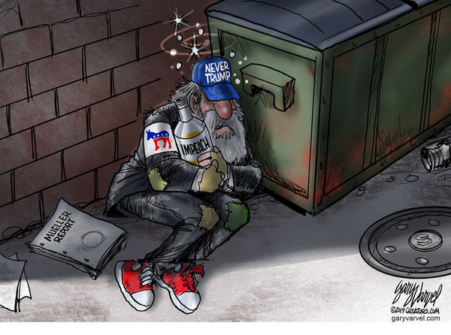
Gary Varvel is among the most recognized political cartoonist. Varvel was a cartoon editor for a daily newspaper for close to sixteen years. Being a sports fan, he sometimes includes some sports captions in his original political cartoons. Recently, he has been showing some concern for the current trends in American politics. In one of his contemporary arts, he brings out an idea about Mueller’s report. The cartoon refers to a statement that was released by Mueller reporting that there is enough evidence to show that there was collusion in Trump’s elections. According to the views of those who believe in the report, Trump should be impeached.
Varvel’s cartoon shows a poor man lying on the street. Besides the man, there is a book written Mueller report ("Political Cartoons by Gary Varvel n.p"). The man is also wearing a cap written NEVER TRUMP. He also holds a bottle written impeach. According to the social state of the person in the picture, he represents the poor in society. Varvel is bringing out an idea that the poor are not pleased with Trump’s leadership. It is evident in the cartoon that the poor agree with the report, and they support the impeachment idea.
Varvel portrays the poor in a hopeless situation. The beggar sleeping on the street next to a trash bin depicts a desperate condition. Varvel has not distorted the person in the cartoon in any way. He portrays a real image of a beggar in the street. The character is expressed in a negative light. The artist aims to show that the poor are the most affected by Trump’s leadership. This is in line with the thoughts of most people below the poverty line. Some leaders also believe that the current government provides little support for the poor.
The man featured in the cartoon has a blue cap and red shoes. His jacket has a picture of a horse colored in red and blue. The two colors represent the Republican Party’s theme colors. This is a clear indication that the cartoon depicts the views of the Republicans. Since the last election, the Republicans have been against the Democrats’ views and agendas. Mueller’s report created an opportunity for the Republicans to campaign for Trump’s impeachment. Though some Republicans have not read the report, they are against Trump’s government.
The cartoon’s message can be first noted through the dressing code of the person in the picture. The theme colors on his clothes are red and blue, symbolizing the Republicans. The words written on his clothes, bottle and the book next to him indicate the current concern of the American people concerning the alleged collusion in the last election ("Gary Varvel for Apr 23, 2019 | Cartoons n.p"). The cartoon depicts that the Republicans, especially the poor, support Mueller’s report. The artist is trying to convince the reader of the art that Mueller’s report is accurate and that Trump should be impeached to save the current condition of the Americans.
Some people understand a message better when put in artwork like cartoons. The artist is, therefore, trying to convince people that Mueller’s report is real and people should take time to read the statements and facts provided. However, I don’t think Varvel is trying to force everyone to believe in the report. The cartoon shows that Republicans are the most interested people in the impeachment issue.

Works Cited
"Gary Varvel for Apr 23, 2019 | Cartoons." Retrieved from www.realclearpolitics.com/cartoons/cartoons_of_the_week/.
"Political Cartoons by Gary Varvel." 29 Apr. 2019, townhall.com/political-cartoons/garyvarvel.

